 Project Report On

**BiteBridge**

Submitted in partial fulfillment for the award of

**Post Graduate Diploma in Advanced Computing**

from

**C-DAC ACTS (Pune)**

**Guided by**

**Mr. Pramod Kondke**

**Presented By**

**Saurav Garje - 240340120177**

**Siddhesh Sangale - 240340120167**

**Aman Poskar - 240340120134**

**Mahima Barde- 240340120096**

**Dipak Patil- 240340120124**

**Ashwini Pawar - 240340120043**

**Table of Contents**

1. Introduction
2. Software Requirement and Specification
3. Tools and technologies used
4. Project Flow Diagram(Database Design)
5. ER Diagram
6. Use Case Diagram
7. Advantages
8. Screenshots
9. Future Scope

10. Conclusion

11. References

1. **Introduction**

BiteBridge is a secure, user-friendly web application tailored for Canteen/Mess/Organizations, facilitating seamless food ordering, token-based payments, and efficient order management. The application incorporates JWT authentication for secure transactions, ensuring user data integrity. It also features real-time order management through Java API integration with a MySQL database, allowing users to easily add, remove, and track their orders. Additionally, the app supports QR code integration for enhanced order verification during pickup, along with a responsive UI designed using CSS to ensure compatibility across devices. A WhatsApp alert system was implemented to provide instant notifications for order purchases, enhancing communication and user experience. The frontend leverages React Hooks for state management, while the backend utilizes Java Spring Boot to securely handle data storage and retrieval.

1. **Software/Hardware Requirement**

**Server:**

Processor: Intel Core i3 or equivalent AMD processor.

RAM: Minimum 8GB RAM.

Storage: SSD storage for improved performance.

Network: Ethernet or Wi-Fi connectivity.

Operating System: Windows 7 and above.

**Client Devices:**

Processor: Dual-core processor or higher.

RAM: Minimum 4GB RAM.

Storage: Sufficient storage for caching and local data.

Network: Ethernet or Wi-Fi connectivity.

Browser: Compatible with latest versions of popular browsers like Google Chrome, Mozilla Firefox, and Safari.

1. **Tools and technologies used**

● Spring Boot

● Spring Data JPA

● RESTful Web

● Spring Web

● MYSQL Database

● JWT

● Spring Security

● React JS

● Axios

● Git

● HTML and CSS

● QR Code

● WhatsApp Norification

● Twilio

1. Spring Boot: Utilized to develop the backend of the application, providing a robust framework for building Java-based web applications with ease.

2. Spring Data JPA: Implemented for data access, allowing seamless interaction with the MySQL database to store and retrieve data efficiently.

3. RESTful Web Services: In the context of a Canteen web application like BiteBridge, RESTful web services play a crucial role in facilitating communication between the frontend and backend components. These services adhere to the principles of Representational State Transfer (REST), which emphasizes a stateless, standardized approach for building web services

4. Spring Web: Used for handling web requests and responses, managing controllers, and serving static resources to the frontend.

5. MySQL Database: Chosen as the relational database management system to store canteen data including admin detail, canteen details ,student details, cart,dish information and order details.

6. JWT (JSON Web Tokens): Implemented for secure user authentication and authorization, ensuring that only authenticated users can access the system.

7. Spring Security:

8. Axios: In the context of a web application like BitBridge, Axios is likely used as a client-side HTTP library. Axios simplifies the process of making asynchronous HTTP requests from the frontend (React.js) to the backend. It is instrumental in fetching data from the server, handling API calls, and facilitating smooth communication between the frontend and backend components, ensuring efficient data retrieval and seamless user interactions in the e-commerce application

8. React: Employed to build the frontend of the application, offering a component-based architecture for creating dynamic and interactive user interfaces.

9. CSS: Used for styling the frontend components with utility-first CSS classes, allowing for rapid prototyping and customization of the user interface.

10. Git: Implemented as a version control system to track changes in the source code, enabling collaboration among developers, and facilitating code management and deployment workflows.

11. QR Code

12. WhatsApp Notification

13. Twilio

1. **Project Database Design**

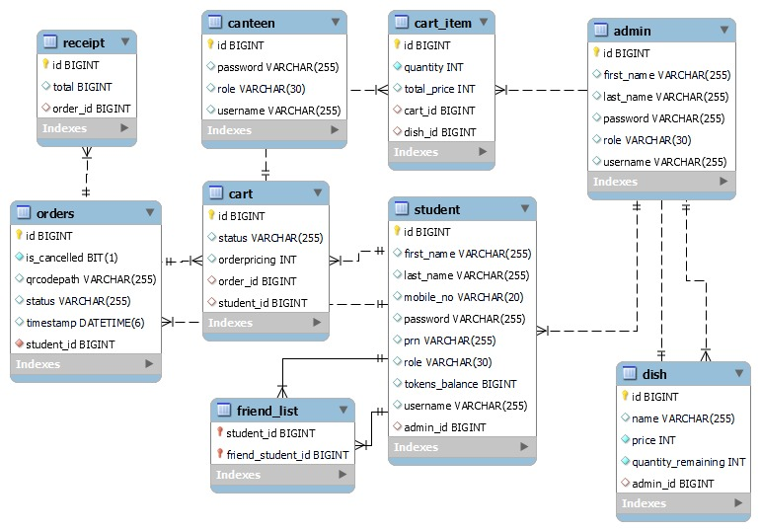

1. **Project E-R(Entity Relationship) Diagram**

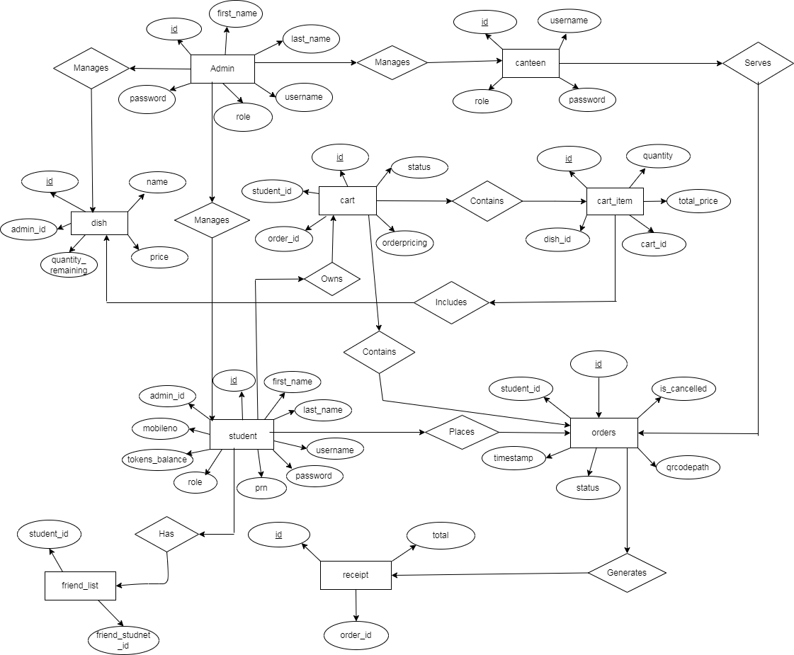

1. **Use Case Diagram**

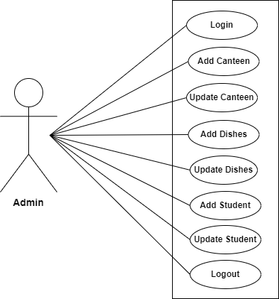

Fig. Use-Case Diagram for Admin

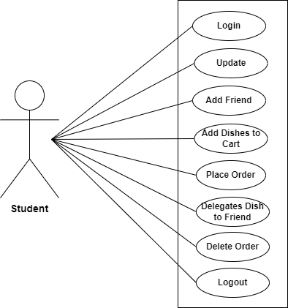

Fig. Use-Case Diagram for Student

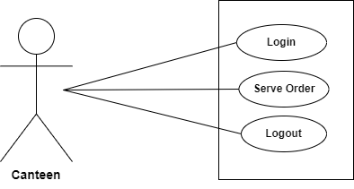

Fig. Use-Case Diagram for Canteen

1. **Advantages**

* Use of JWT for authorization

○ Stateless Authentication: JWT allows for stateless authentication, meaning server-side sessions or database lookups for authentication are not required, resulting in reduced server load and improved scalability.

○ Enhanced Security: JWTs are digitally signed, ensuring data integrity and preventing tampering or unauthorized access to user data. Additionally, since JWTs do not store sensitive information, they mitigate the risk of data exposure in case of a breach.

○ Cross-Domain Compatibility: JWTs can be easily transmitted over HTTP headers or URLs, making them suitable for use in cross-domain communication and enabling seamless integration with various frontend and backend technologies.

1. **Screenshots**

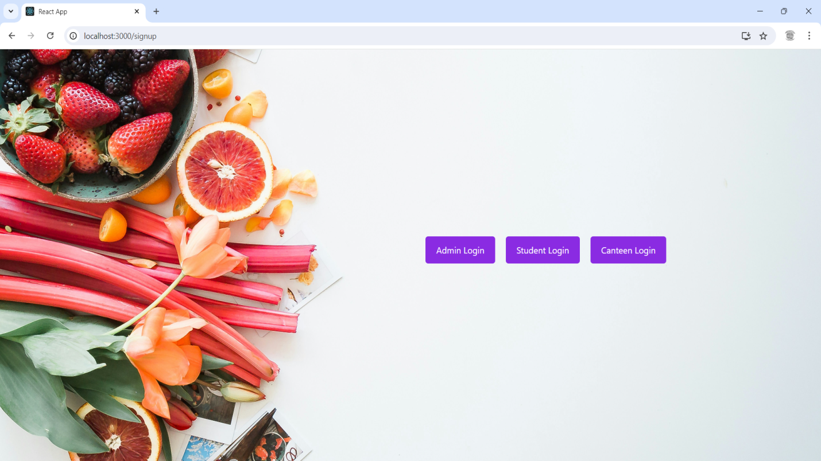

**Fig.1-Home Page**

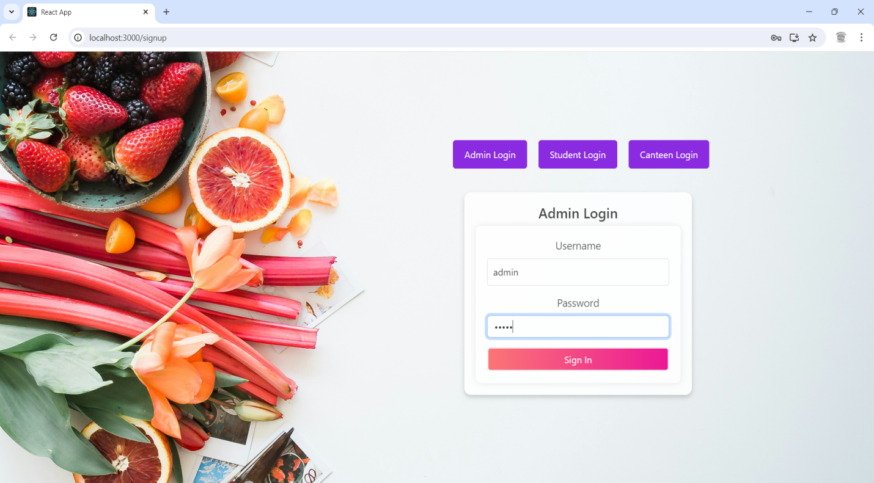

**Fig.2-Admin Login Page**

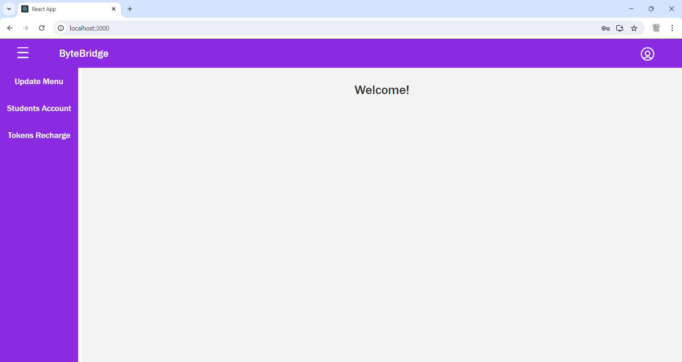

**Fig.3-Admin Home Page**

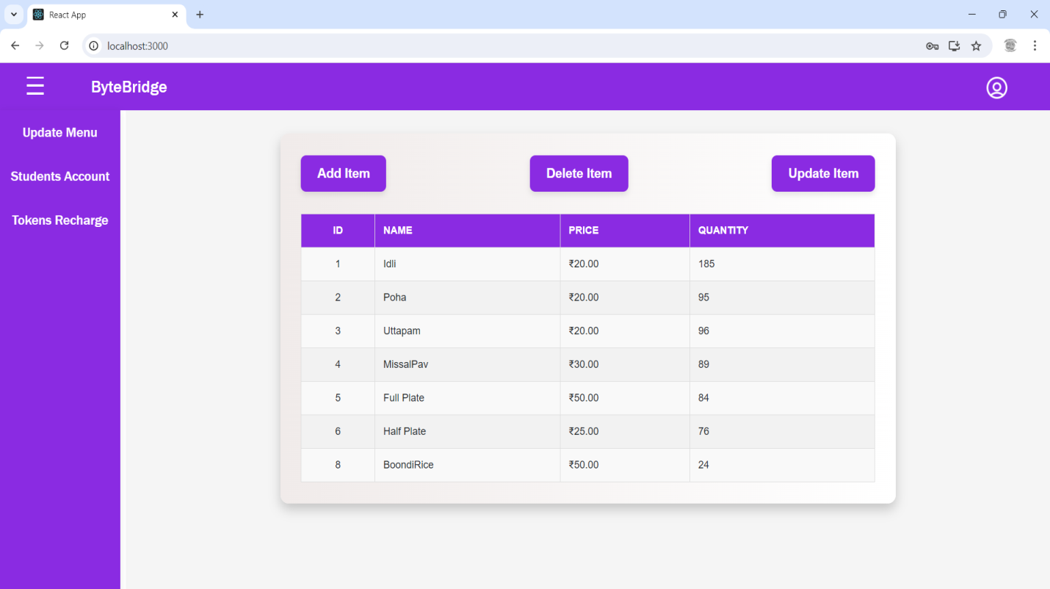

**Fig.4-Admin Update Menu Page**

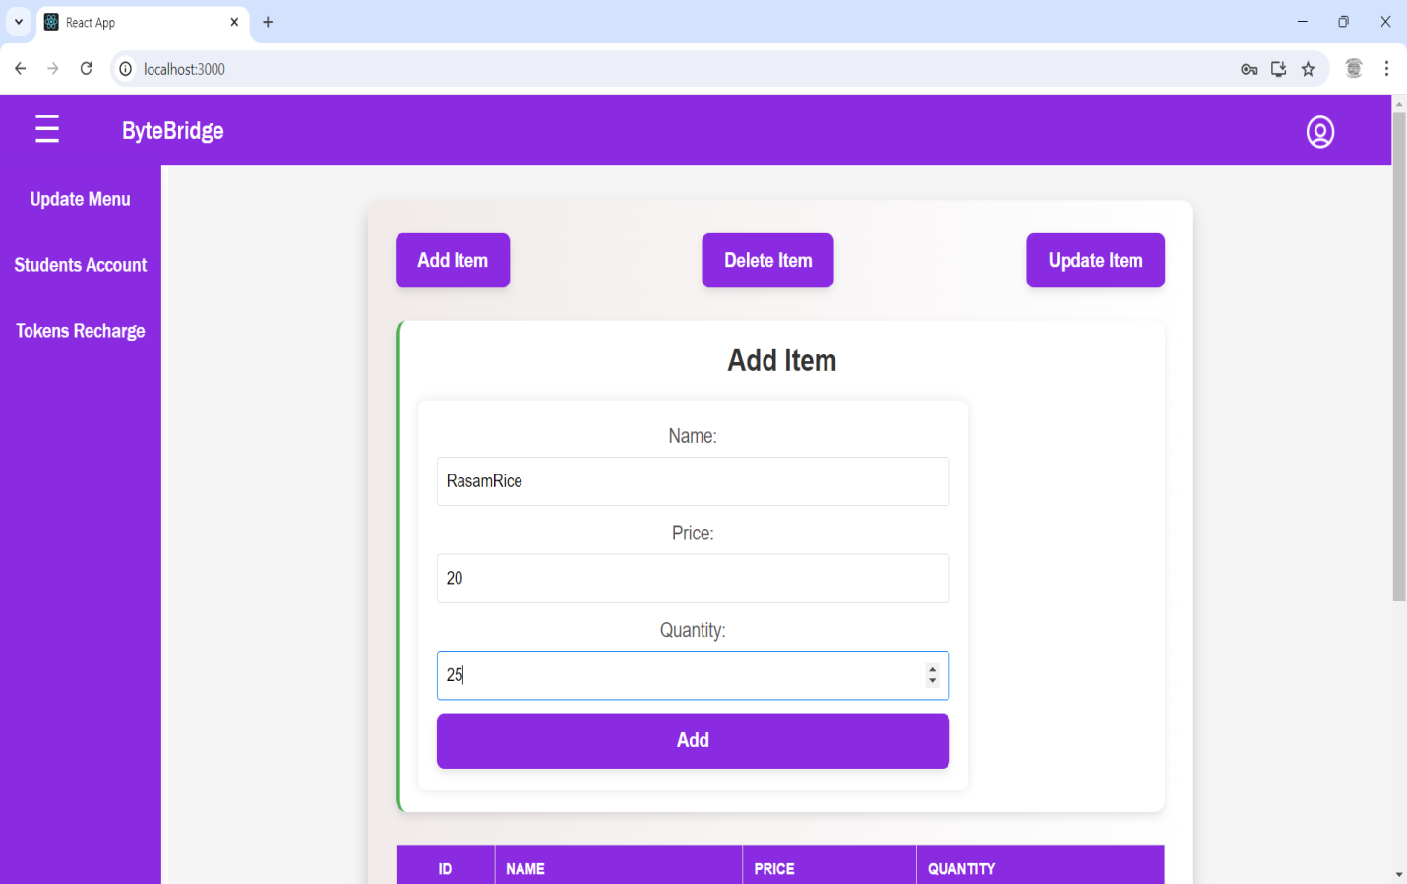

**Fig.5-Admin Add Dish Item Page**

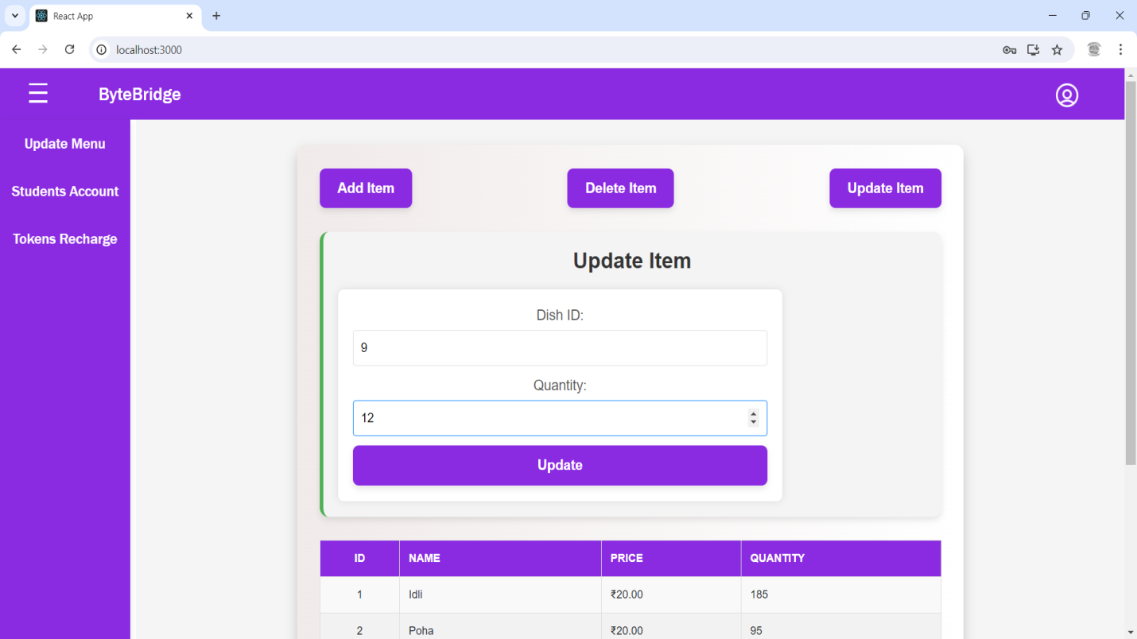

**Fig.6-Admin Update Dish Item Page**

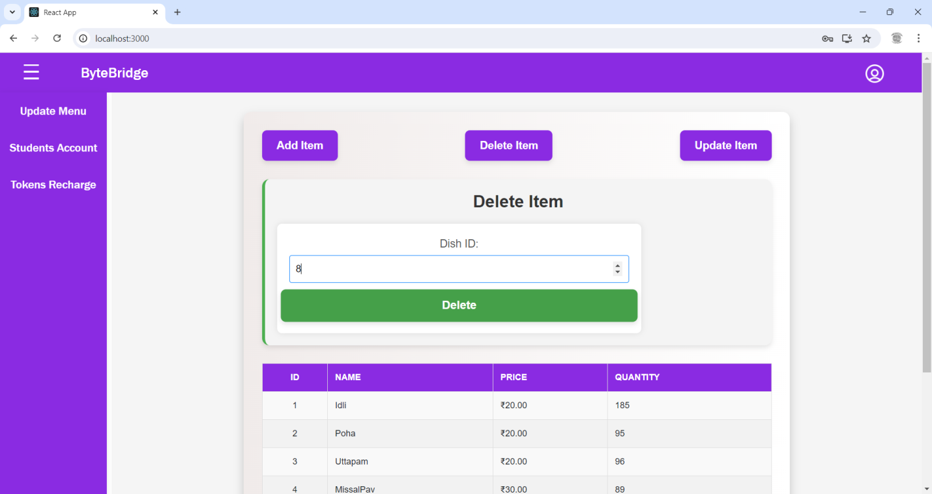

**Fig.7-Admin Delete Dish Item Page**

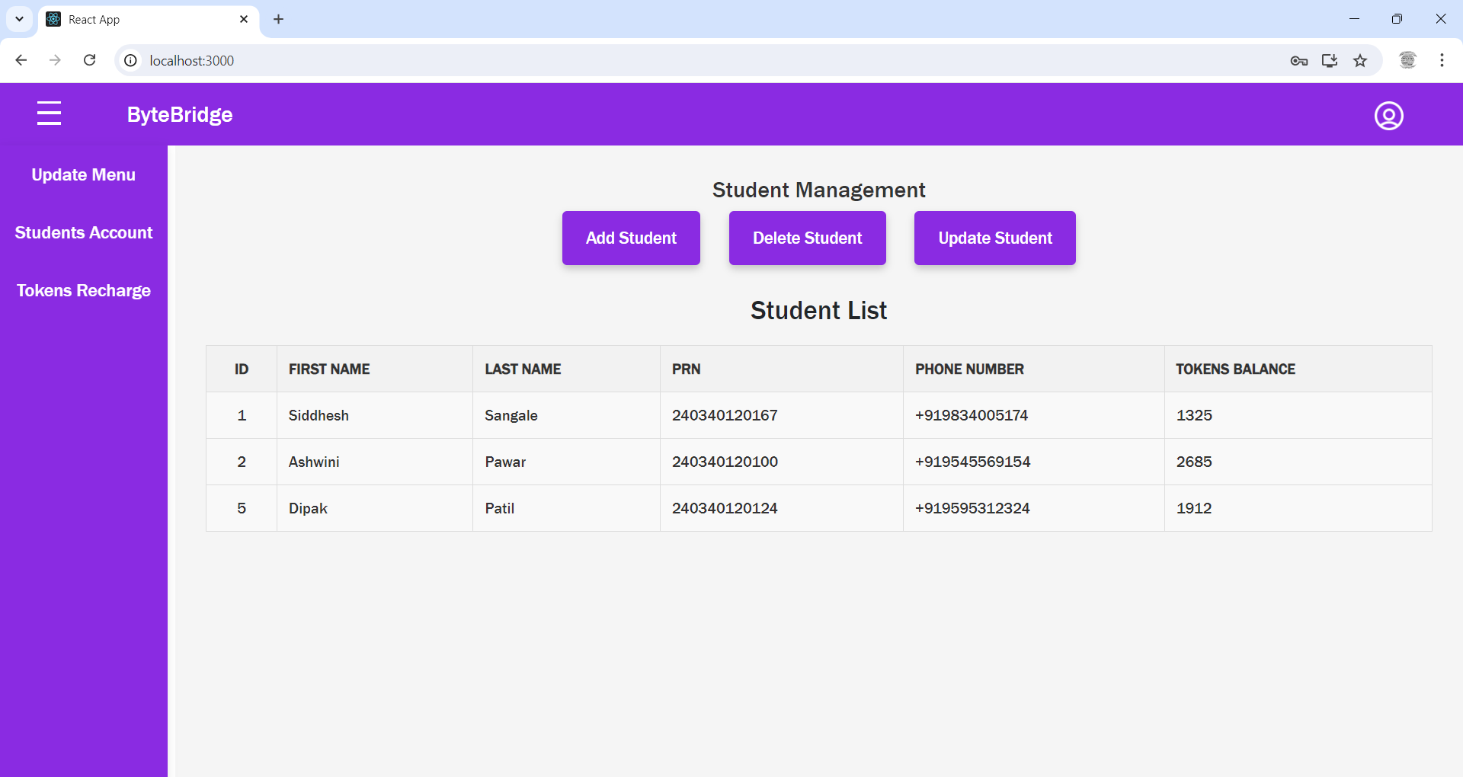

**Fig.8-Admin Students Account Page**

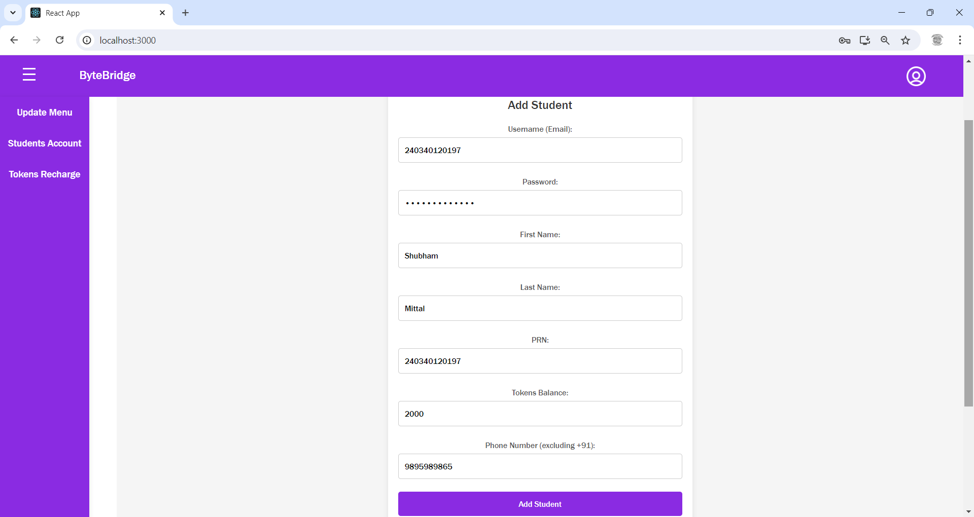

**Fig.9-Admin Add Student Page**

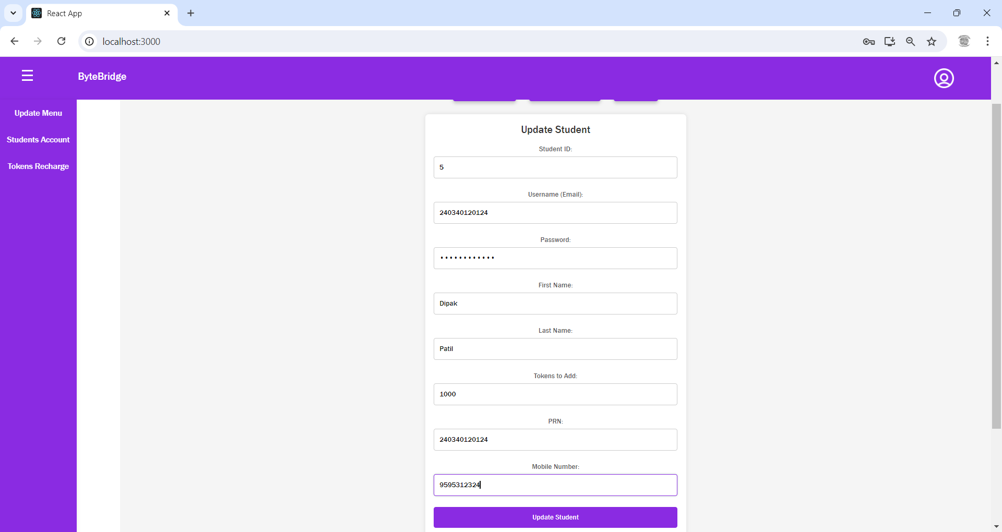

**Fig.10-Admin Update Student Page**

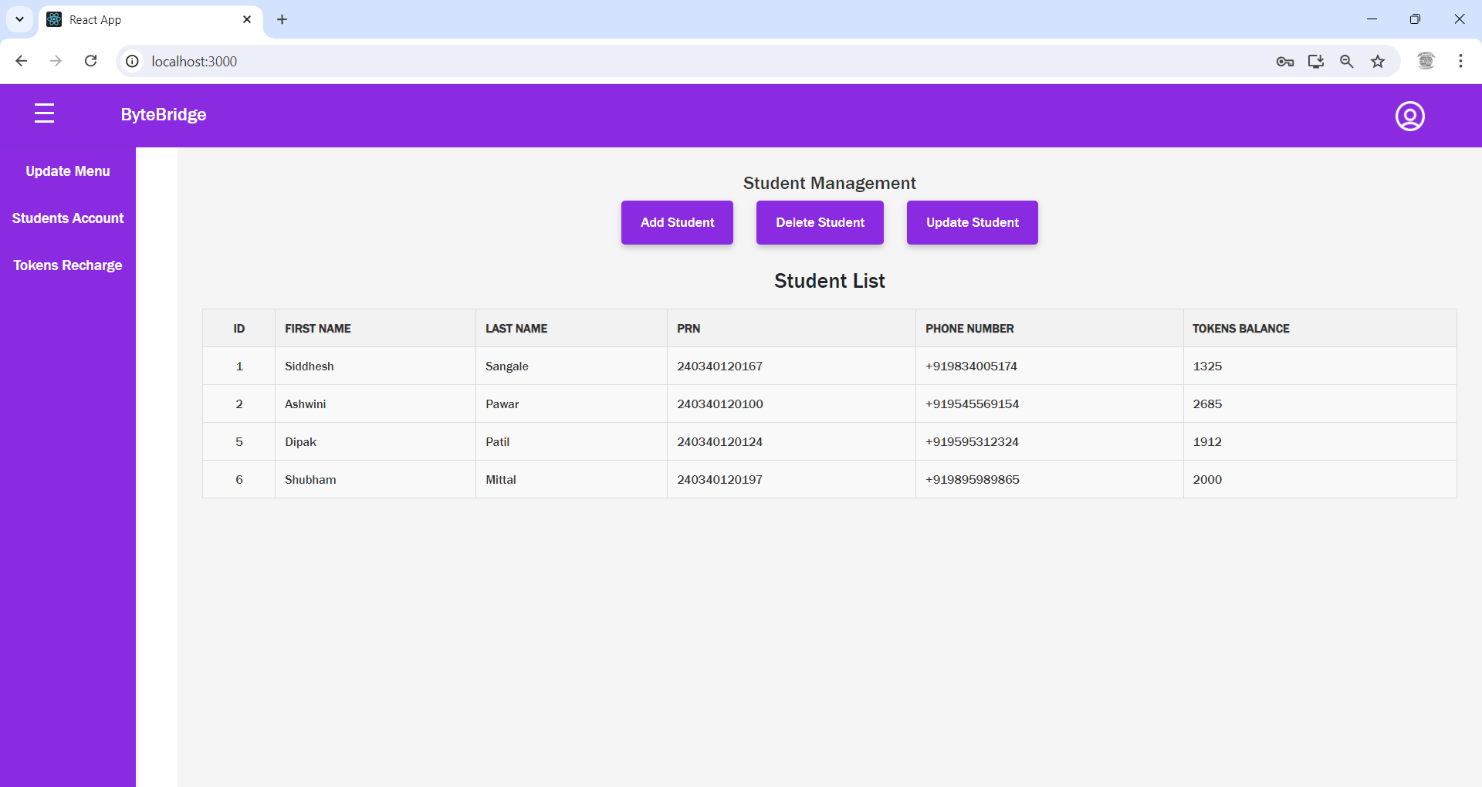

**Fig.11-Admin after Student Add Page**

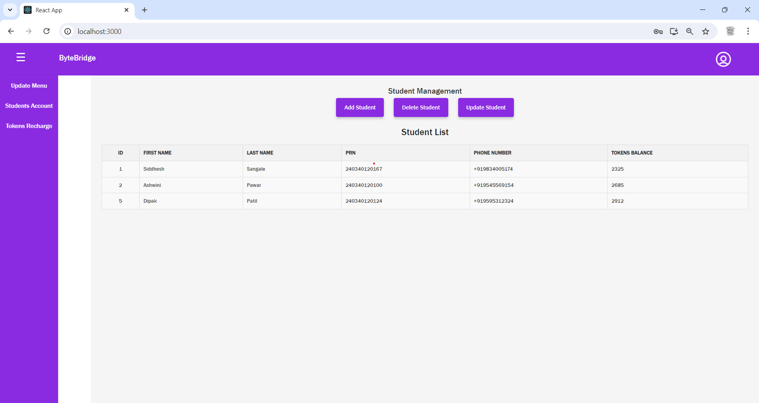

**Fig.12-Admin after Student Update Page**

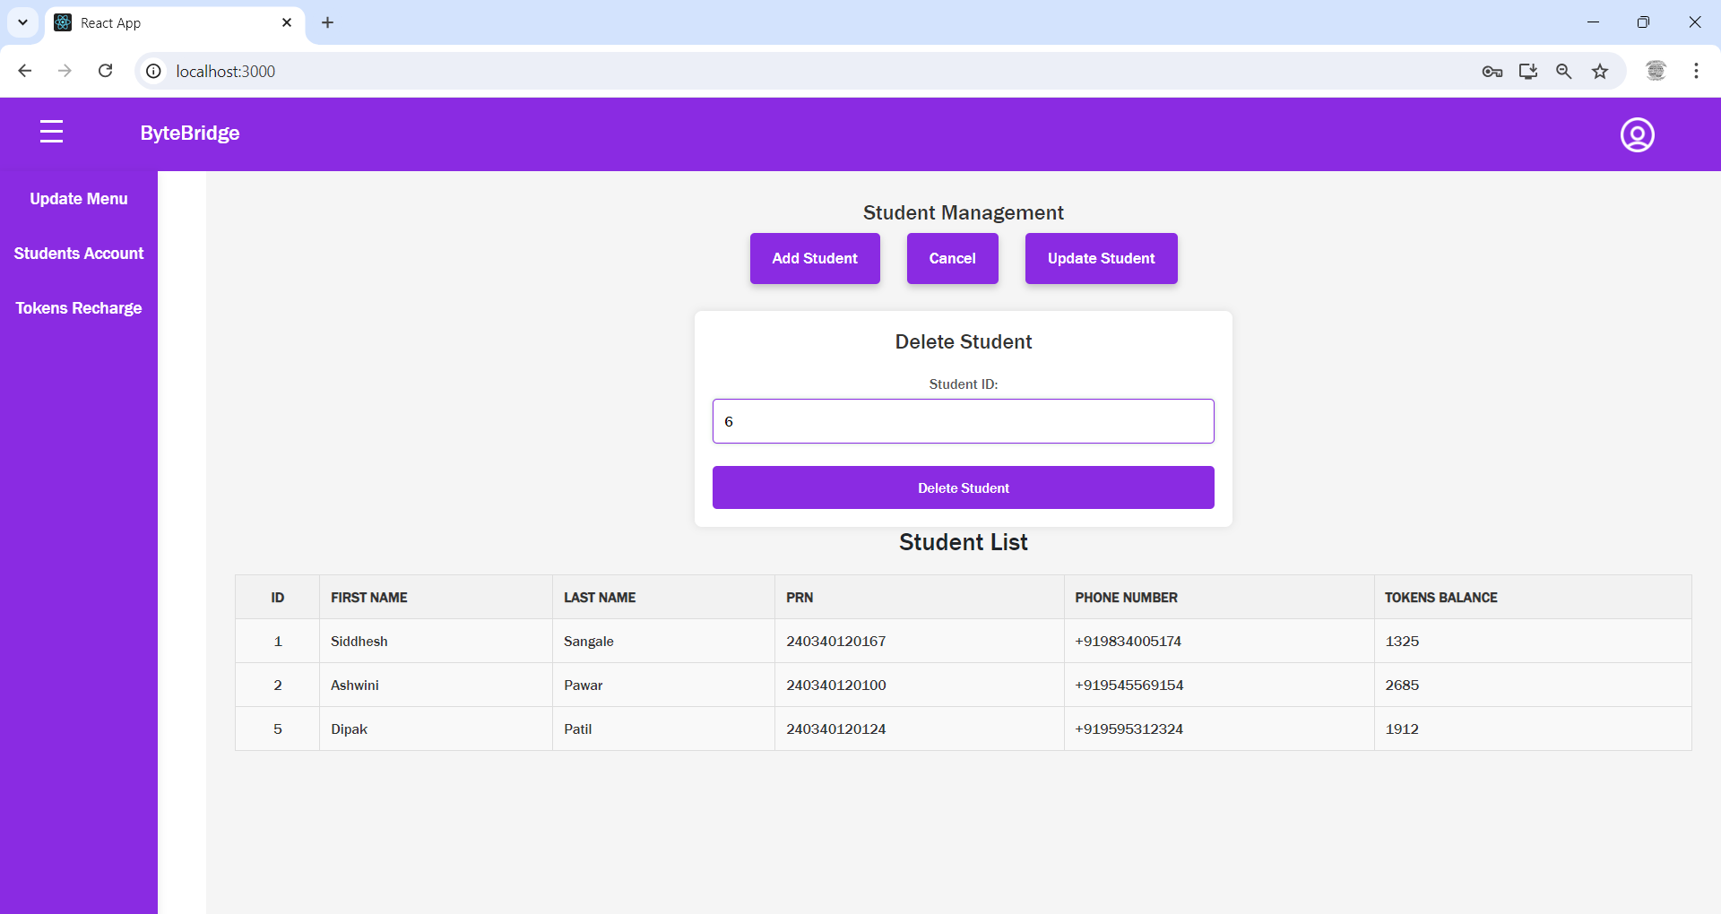

**Fig.13-Admin Delete Student Page**

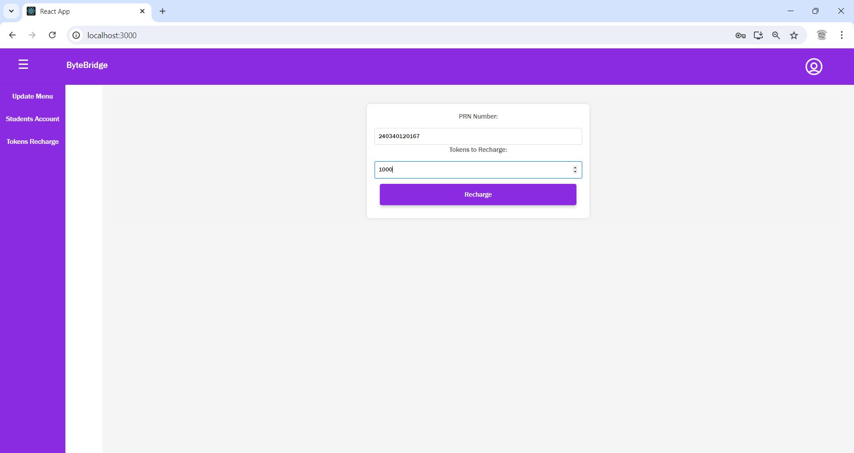

**Fig.14-Admin Student Token Recharge Page**

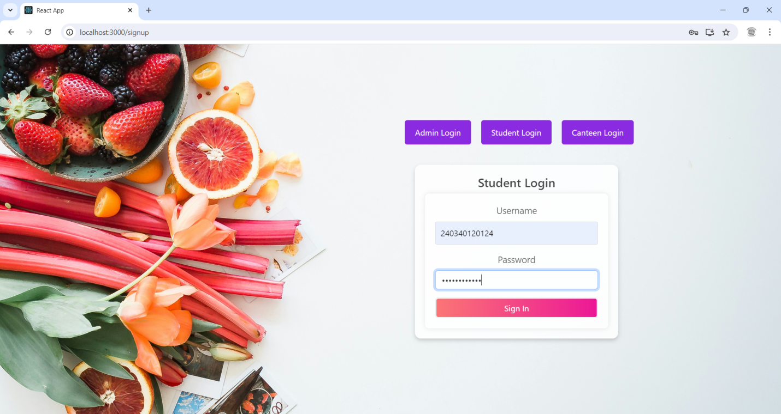

**Fig.15-Student Login Page**

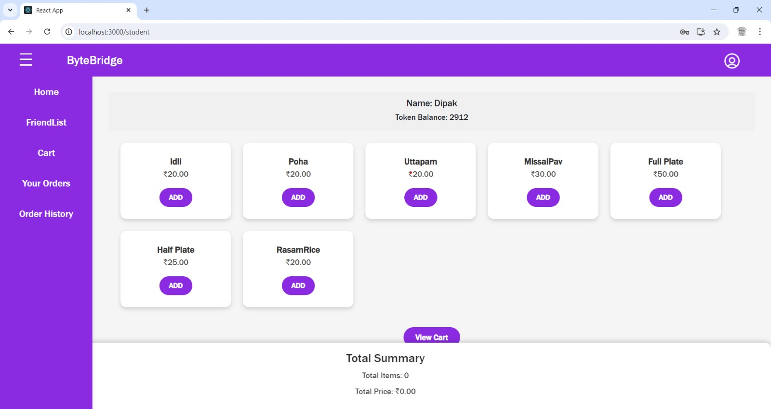

**Fig.16-Student Home Page**

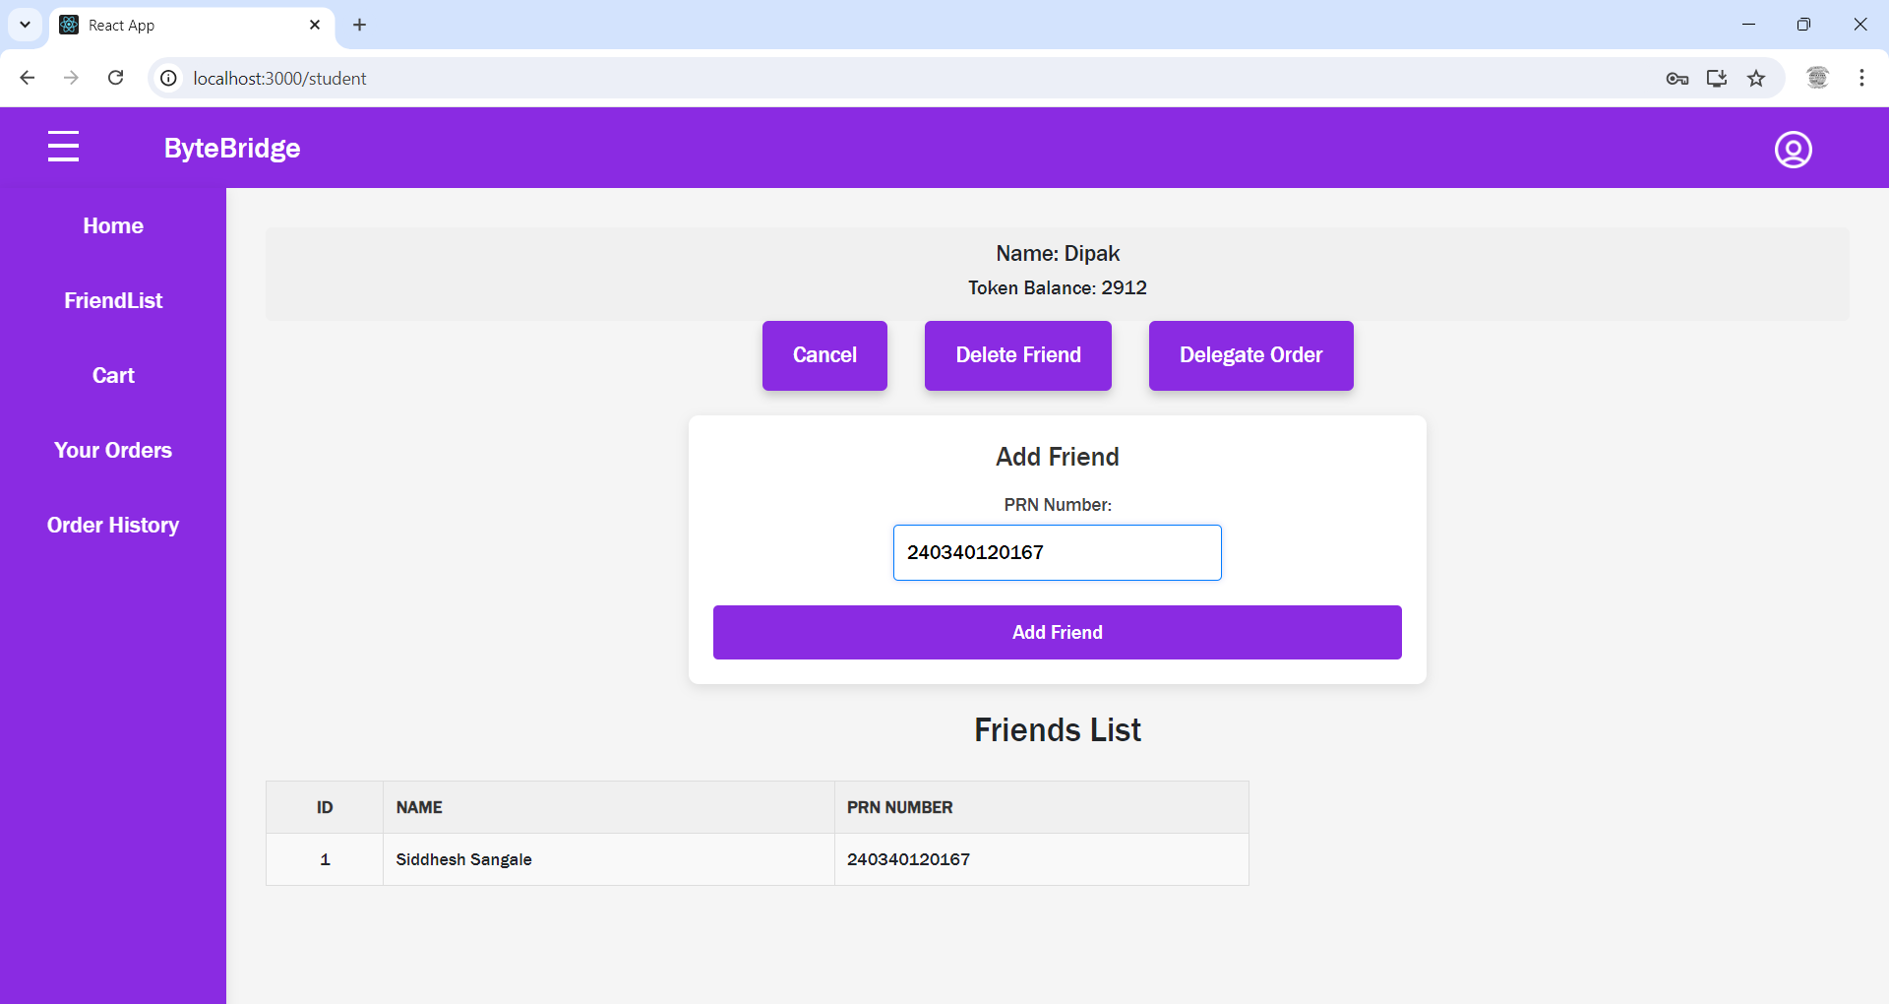

**Fig.17-Student Add Friend Page**

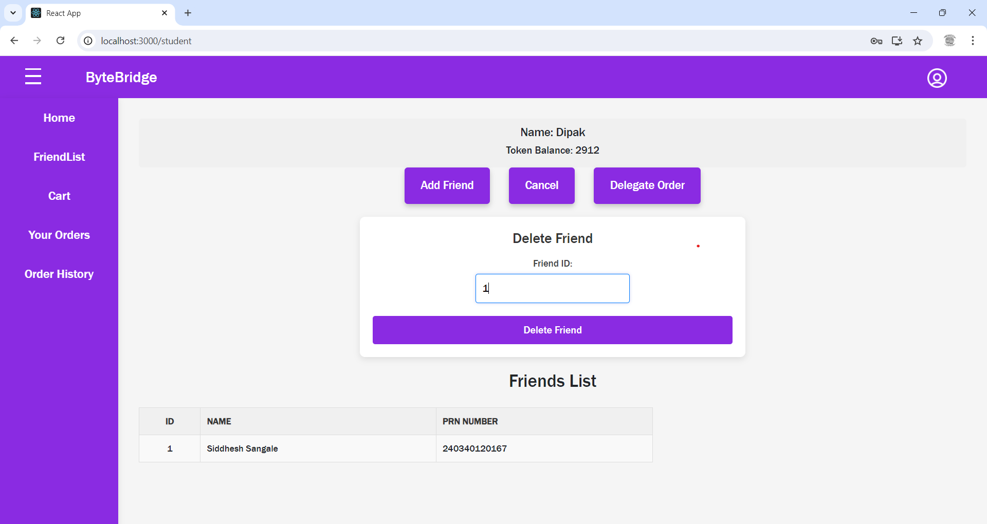

**Fig.18-Student Delete Friend Page**

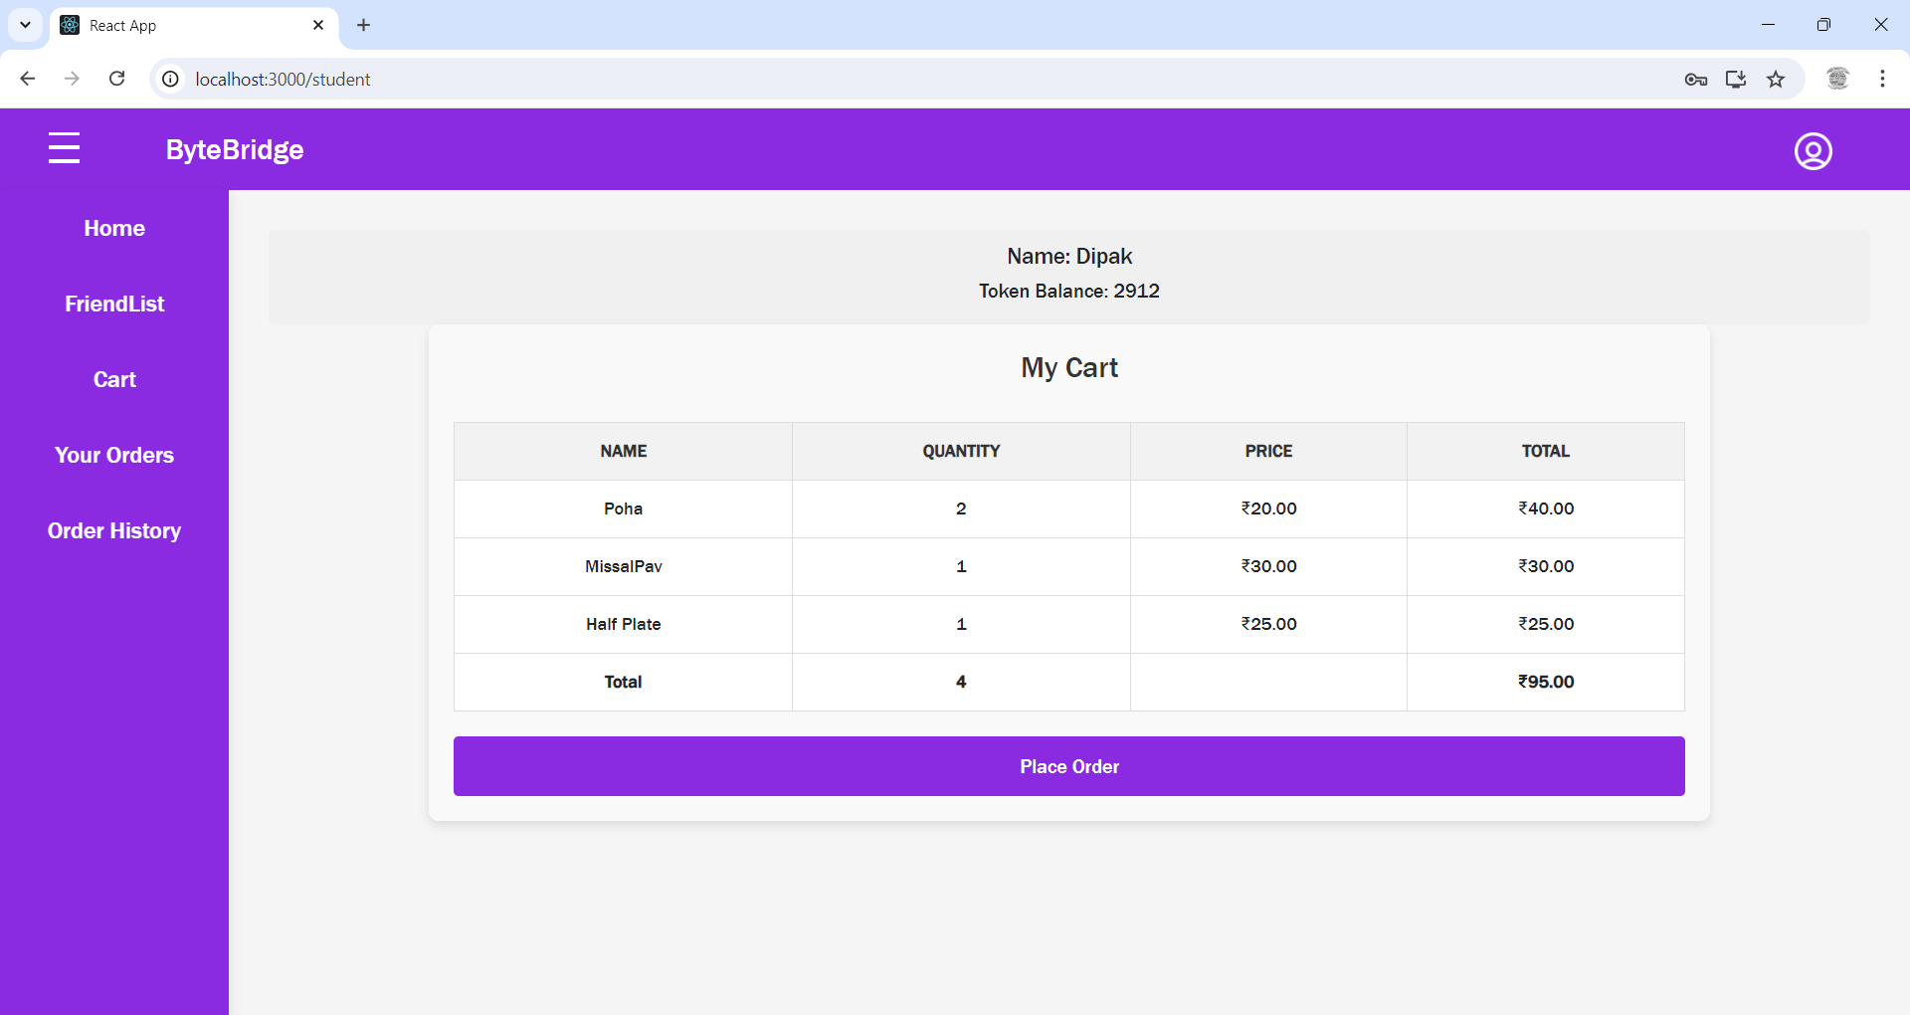

**Fig.19-Student Cart Page**

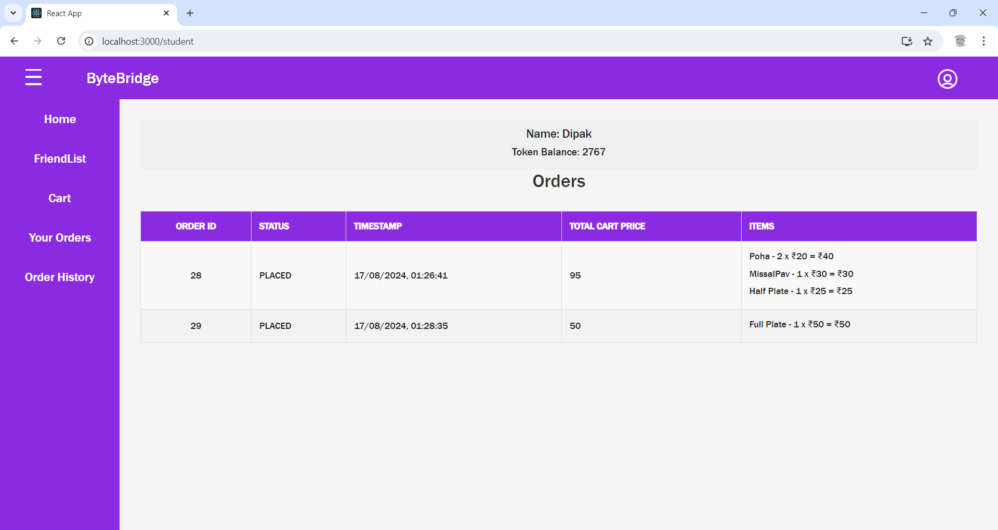

**Fig.20-Student Orders Page**

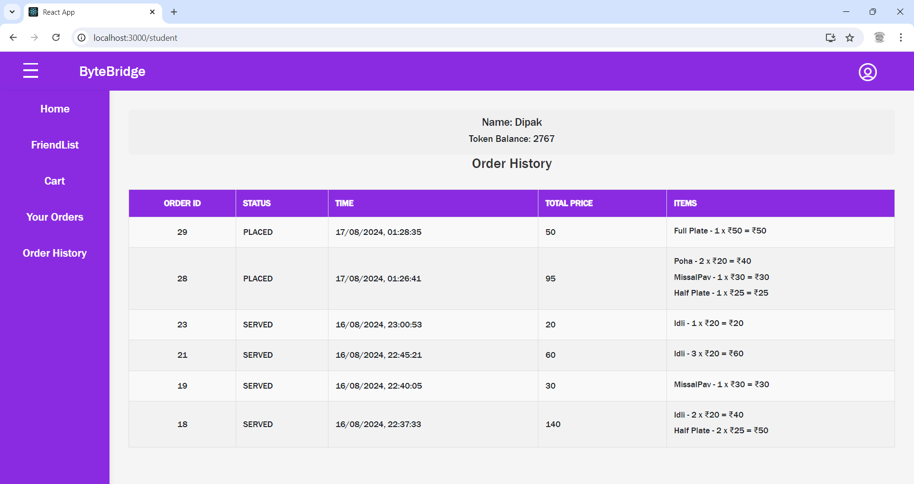

**Fig.20-Student Order History Page**

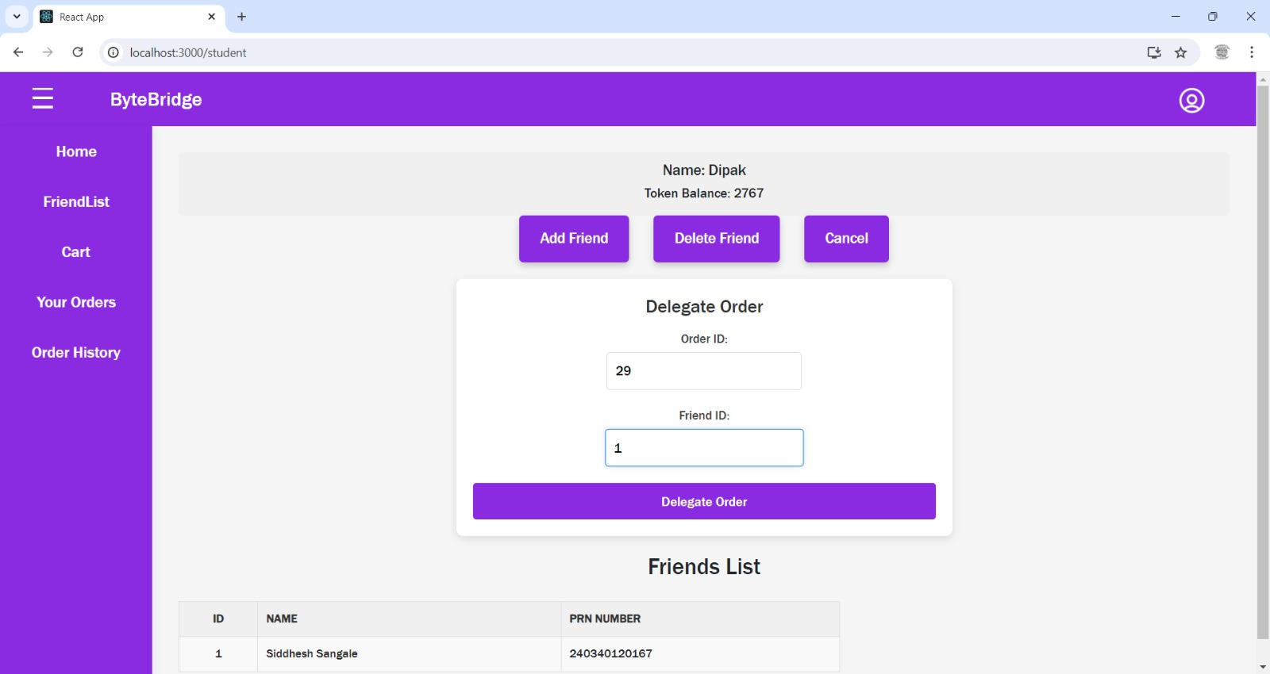

**Fig.21-Student Delegate Order to friend Page**

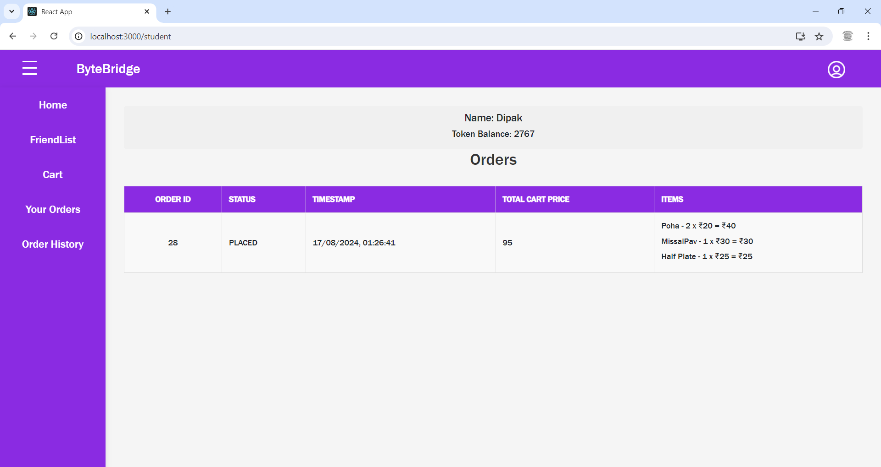

**Fig.22-Student Order After delegating to friend**

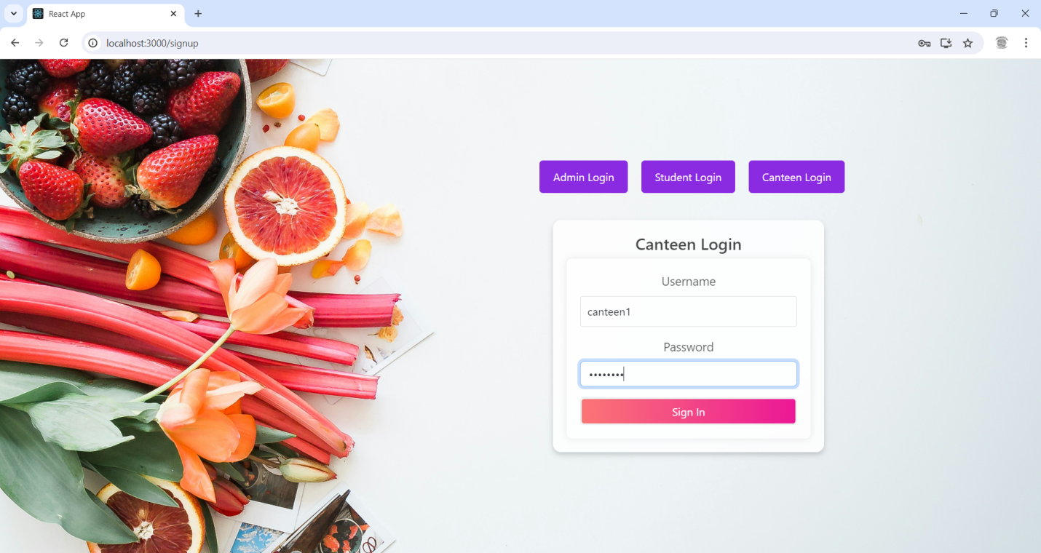

**Fig.23-Canteen Login Page**

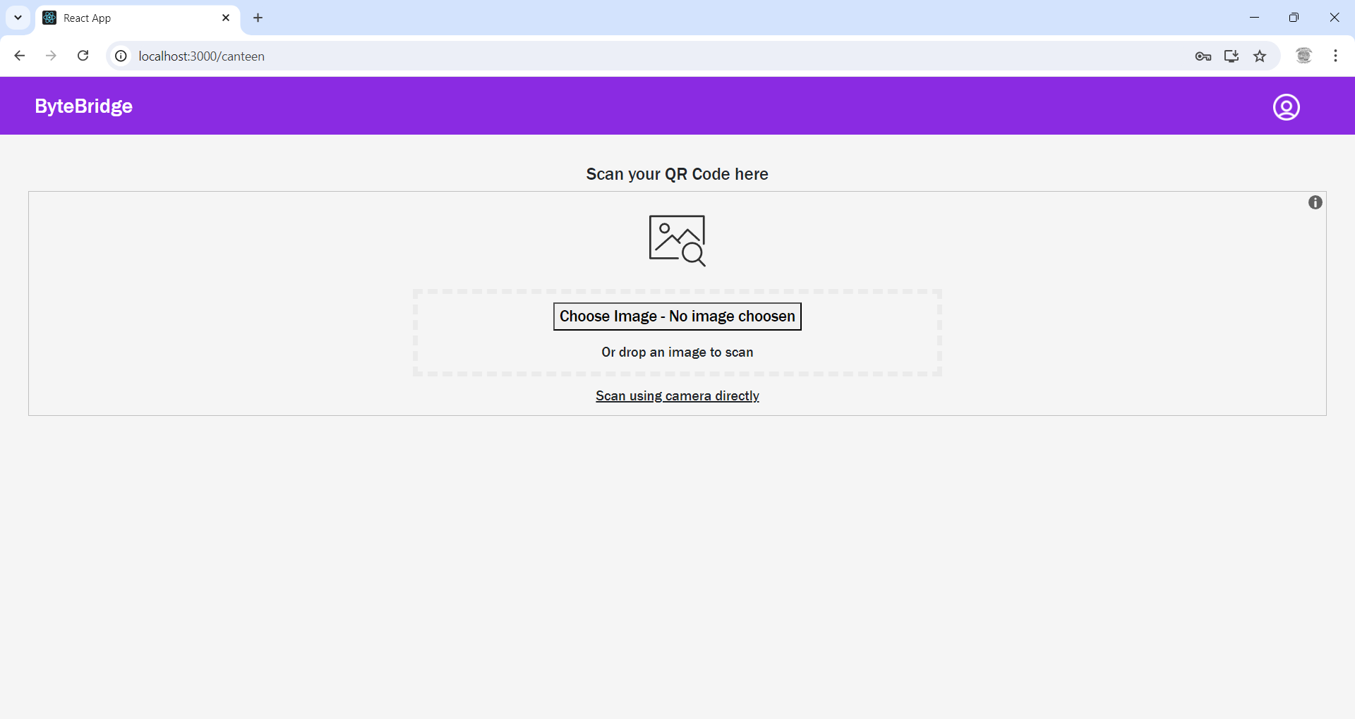

**Fig.24-Canteen Home Page**

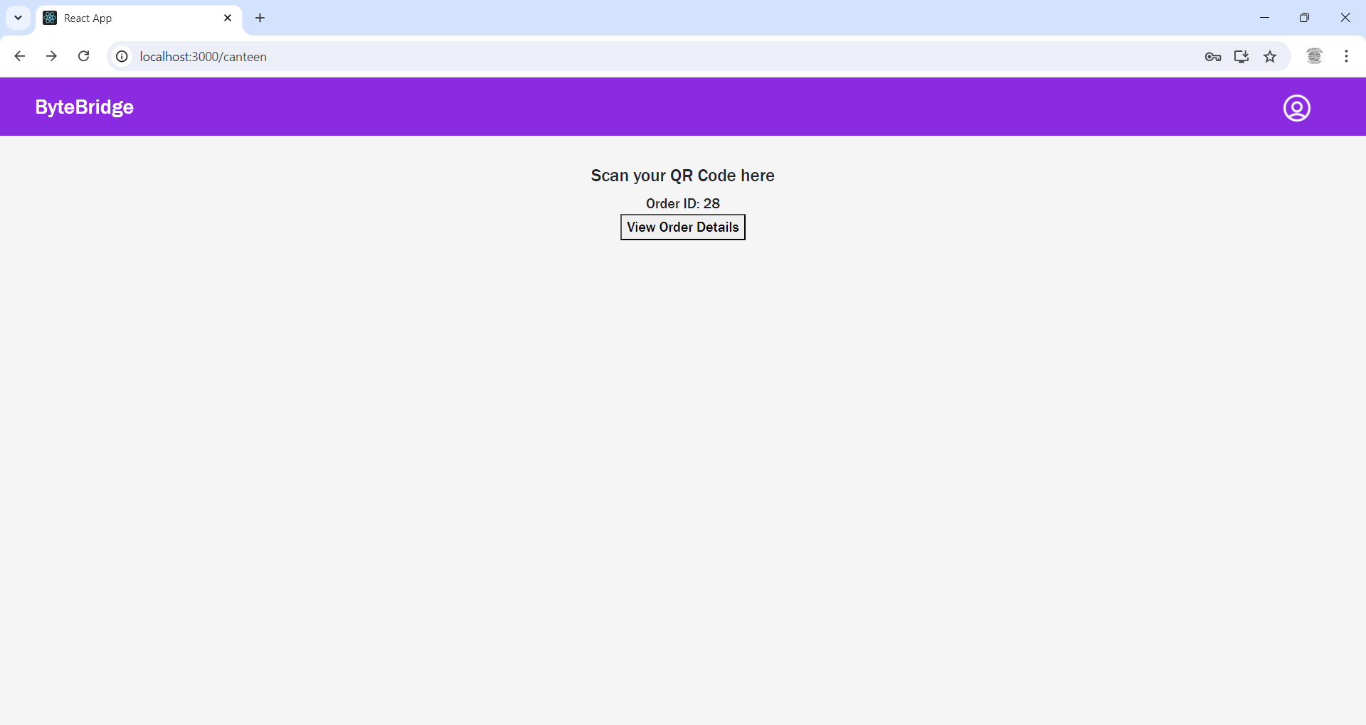

**Fig.25-Canteen Scan Id**

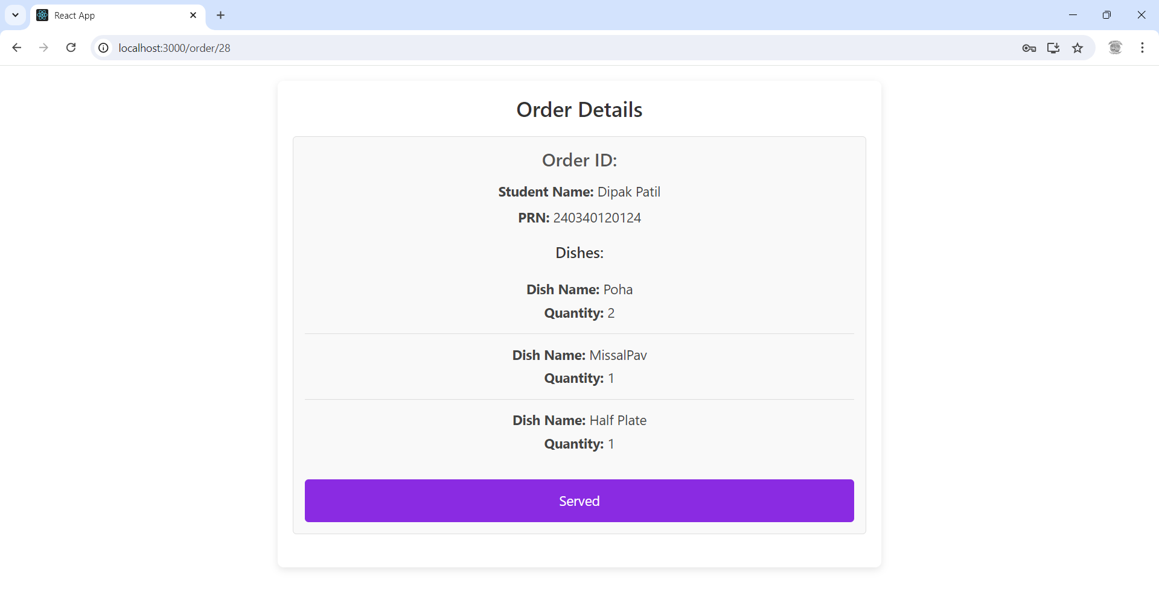

**Fig.26-Canteen Order Receipt**

1. **Future Scope**

* Integrating payment Gateway
* Implementing Filters to check the order status response
* Google Auth implementation
* Mobile Application Development
* OTP notification generation

**10.Conclusion**

The "BiteBridge" project successfully integrates a range of cutting-edge technologies to deliver a comprehensive platform. Leveraging Spring Boot, Spring Data JPA, and RESTful Web Services ensured robust backend functionality for user authentication and data retrieval. The BiteBridge Project embodies a comprehensive and user-centric approach to online food order. Leveraging technologies like Spring Boot, React.js, and MySQL database, it provides a robust and scalable platform. With seamless user-friendly interfaces, and a responsive design, BiteBridge aims to deliver an immersive food ordering experience.

The BiteBridge Canteen Management System successfully addresses the needs of modern canteen operations by providing a streamlined, user-friendly platform for ordering and managing food items. Students benefit from the convenience of browsing menus, placing orders, and making payments directly through the system with tokens, generating QR code for placed order, sending notification on WhatsApp which reduces wait times and improves satisfaction. Administrators gain robust tools for overseeing dish availability, processing orders, and managing transactions, enabling them to run the canteen efficiently.

Overall, the BiteBridge CMS not only simplifies the ordering process but also ensures that the canteen operates smoothly, with accurate records of all transactions. It fosters a more organized, accessible, and responsive canteen environment, ultimately contributing to a better dining experience for all users involved.

**10. References**

1. <https://spring.io/projects/spring-boot>

2. <https://spring.io/projects/spring-data-jpa>

3. <https://restfulapi.net/>

4. <https://www.mysql.com/>

5. <https://spring.io/projects/spring-web>

6. <https://reactjs.org>

7. <https://www.twilio.com>